MS/MPhil Proposal Form for BASR

Presentation Date: | …………………………. | Program (Dept): MS (Mathematics & Scientific Computing
Name of Student: Muhammad Umair Arif |  | Registration No. (Complete): 20242-35517
Date of Admission: | 01-01-2024 | Course Completed (semester): | …………………………
Name of Supervisor: | Dr. Faiza Rubab Co-Supervisor (If any): ……………………….
Title of Thesis (Capitalize Each Word): | Mathematical design and analysis of a parametrized activation function for imporved neural network optimization
Note: A word count of 1500 (Maximum) with a font size of 11 (Times New Roman).
Only the relevant references should be added.
 |  | Yes | No
a) | Correspond to the community needs at the regional and local levels
b) | National Research Agenda
c) | Signifies emerging areas of research that coincide with SDGs # | ________________________

- Introduction and Literature Review Summary

Deep neural networks rely heavily on activation functions to set up the learning behavior and computational performance. They add non-linearity to the neural networks, and affect key properties such as gradient propagation, convergence, representation capacity, and training efficiency . Therefore, the study of activation functions has been an active research field in deep learning.

In early neural networks common sigmoid and hyperbolic tangent functions can result in very small gradients in deep networks because of their saturation properties. Rectified Linear Units (ReLU) were shown to be useful by Nair and Hinton (2010). Glorot et al. (2011) showed that rectifier-based networks can be trained effectively in deep learning. Then ReLU was one of the most popular activation functions due to its simplicity and good gradient behavior in positive region. But its zero output and zero derivative for negative inputs led to the development of alternatives. Maas et al. (2013) experimented with leaky rectifiers, He et al. (2015) introduced Parametric ReLU (PReLU) and Clevert et al. (2016) developed the Exponential Linear Unit (ELU). Later, Klambauer et al. (2017) proposed SELU to encourage neural networks to behave in a self-normalizing way.

Subsequent research focused on activation functions that were smooth and non-monotonic. The GELU function was suggested by Hendrycks & Gimpel (2016), whereas Elfwing et al. (2018) worked on Sigmoid-Weighted Linear Unit (SiLU) function. Ramachandran et al. (2018) used automated search and developed the Swish function. The work of Misra (2020) gave rise to the development of Mish function, which is also a smooth and non-monotonic function.

In more recent years, studies on activation functions with adaptive, parameterized, and hybrid properties have been done. Studies like RSigELU, APTx, and others have tried to optimize aspects like gradient flow, convergence, or computation speed. Ven and Lederer (2021) used mathematics to study the issue of vanishing gradients in sigmoid networks, whereas Zou (2024) worked on an activation function with parameterization meant to deal with this issue. RoSwish was developed by Zhang and Ren (2025), which incorporated adaptive parameters into Swish's structure. It is evident that these functions can be constructed mathematically using parameters.

In addition to this, the increasing availability of activation functions makes a comparative study essential. Dubey et al. (2022) presented a comprehensive review of activation functions, along with benchmarking results, while Kunc and Kléma (2024) surveyed hundreds of activation functions which were designed over several decades. Zhang et al. (2024) studied the approximation capabilities of neural networks using activation functions other than ReLU. From these studies, we can infer that the performance of an activation function must be evaluated on the basis of various aspects such as prediction accuracy, gradients, convergence, and computation.

There is a scope for researching a novel activation function with mathematically justified components in light of current literature. The research proposed will look into the mathematical properties of the activation function, including how its derivative and gradient behave. Its effectiveness will then be analyzed against other proven activation functions like ReLU, PReLU, ELU, GELU, SiLU/Swish, and Mish. Other factors to consider include training time and convergence rate. This is meant to find out whether the formulation proposed can offer a proper trade-off between gradient flow, efficient training, and neural network effectiveness.

- Problem Statement
Even after years of research on developing activation functions for deep neural networks, there have been certain limitations that have remained associated with these functions, which have required a balance between properties like gradient propagation, convergence, prediction accuracy, and computation speed. For example, ReLU is efficient in terms of computations but has a dead zone for negative input values, while functions like GELU, Swish, and Mish are mathematically complicated.
Moreover, the availability of an ever growing number of activation functions renders it challenging to ascertain whether there is any significant benefit of a new activation function over existing ones. Therefore, there is a need for a mathematically motivated parameterized activation function which can be rigorously analyzed.
The problem being addressed this research is to create a parameterizable activation function and analyze it mathematically to see whether it enhances gradient flow and efficiency during training while still retaining good predictive performance in comparison to existing activation functions. The function will be tested both mathematically and experimentally based on parameters like gradient flow, speed of convergence, training time, and performance of the model.

- Study Objectives/ Questions

  - Study Objectives
The main objective of this study is to develop and mathematically analyze a parameterized activation function for deep neural networks and evaluate its effectiveness in terms of gradient propagation and training efficiency.
The specific objectives are:
- To design a mathematically motivated parameterized activation function for deep neural networks.
- To investigate the mathematical properties of the proposed activation function, including continuity, differentiability, range, asymptotic behavior, and derivative characteristics.
- To analyze the gradient behavior of the proposed function and investigate its potential to mitigate gradient attenuation during neural-network training.
- To evaluate the convergence behavior and training efficiency of neural networks using the proposed activation function.
- To compare the proposed activation function with established functions such as ReLU, PReLU, ELU, GELU, Swish/SiLU, and Mish.
- To assess computational performance using measures such as training time, number of epochs required for convergence, loss, and predictive accuracy.
- To determine the effect of the parameters of the proposed activation function on its mathematical behavior and neural-network performance.

  - Research Questions

The study will address the following questions:
- How can a parameterized activation function be mathematically constructed to provide favorable gradient propagation in deep neural networks?
- What are the mathematical properties of the proposed activation function and how do its parameters influence its behavior?
- Does the proposed activation function reduce gradient attenuation compared with commonly used activation functions?
- Does the proposed activation function improve convergence and training efficiency compared with established activation functions?
- How does the proposed function perform in terms of predictive accuracy and loss compared with ReLU, PReLU, ELU, GELU, Swish/SiLU, and Mish?
- How do changes in the proposed function's parameters affect gradient behavior, convergence, and computational performance?

- Research Model/Hypothesis

  - Research Model
The proposed research model is based on the assumption that the selection of an activation function determines the learning behavior of the deep neural network.
The study will examine the relationship:

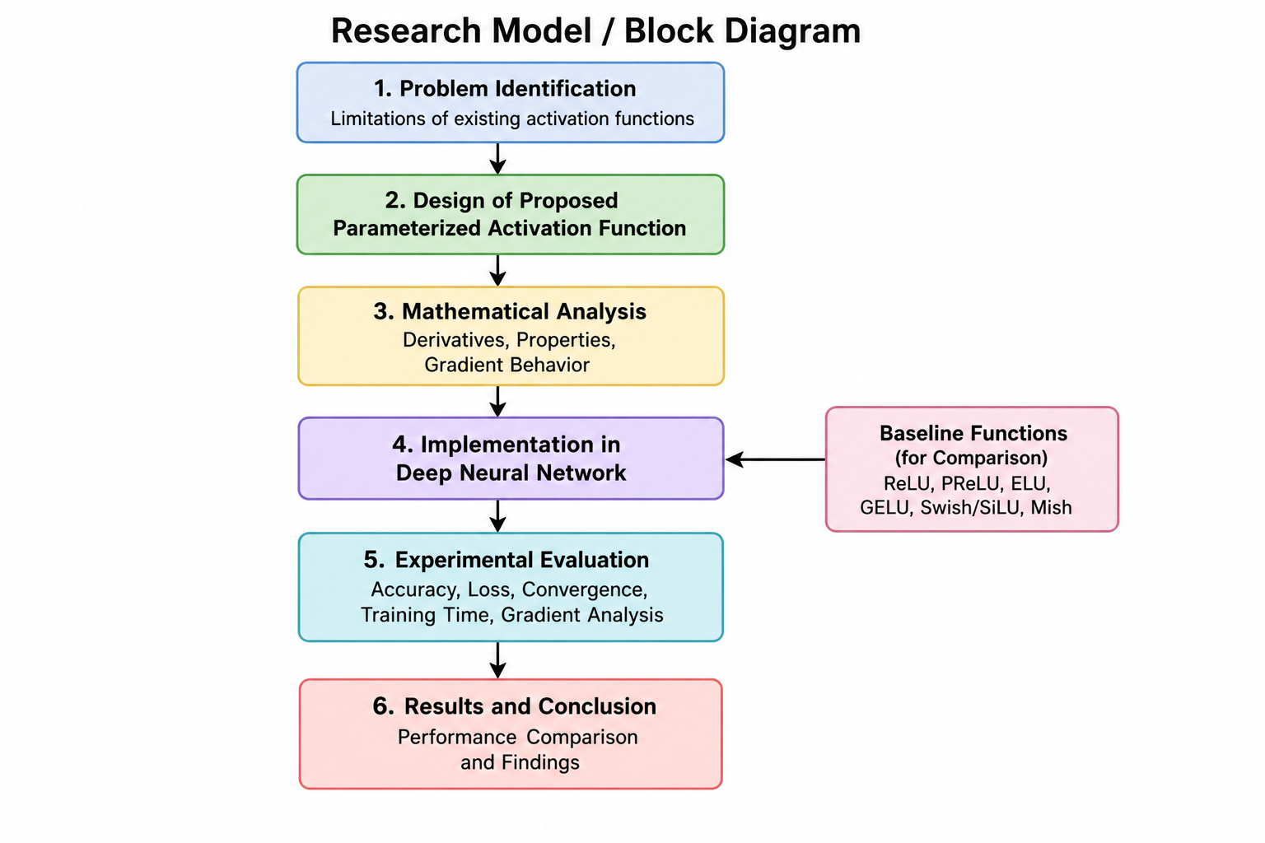
The independent variable will be the activation function, consisting of the proposed parameterized function and established functions such as ReLU, PReLU, ELU, GELU, Swish/SiLU, and Mish.
The dependent variables will include:
- Gradient behavior
- Training loss
- Validation/test accuracy
- Number of epochs required for convergence
- Training time
- Computational efficiency

- Research Methodology
  - Data Collection
The study will use publicly available benchmark datasets rather than collecting data from human participants. MNIST will first be used for digit recognition, while CIFAR-10 can potentially be applied to test the suggested activation function on a harder problem of image classification.

All preprocessing methods, neural network architecture, optimizer, batch size, learning rate parameters, and training conditions will remain the same for all activation functions. The proposed activation function will be compared with some well established activations fucntions including:

- ReLU
- PReLU
- ELU
- GELU
- Swish/SiLU
- Mish

  - Sample Size

For the initial experiments, the following datasets will be considered:

Data Set | Task | Classes | Training Samples | Testing Samples
MNIST | Handwritten digit classification | 10 | 10000 | 2000
Cat vs Dogs | Image classification | 2 | 10000 | 2000

  - Mathematical Analysis

The proposed activation function will first be studied theoretically. The analysis will include:

- Continuity
- Differentiability
- First and higher-order derivatives
- Monotonicity
- Boundedness/unboundedness
- Behavior near zero
- Asymptotic behavior
- Parameter sensitivity
- Gradient behavior

The derivative of the proposed function will be analyzed to investigate whether its mathematical structure can help reduce gradient attenuation during backpropagation.

  - Experimental Analysis

The proposed activation function will then be implemented in a deep neural network and compared with the selected baseline functions under identical experimental conditions. The following performance measures will be recorded:

- Accuracy
- Training/Validation loss
- Number of Epochs
- Training time
- Gradient behaviour
- Computational cost
  - Analytical Techniques:

The experimental results will be analyzed using:
- Descriptive statistics — mean, standard deviation, minimum and maximum values.
- Convergence analysis — comparison of loss and accuracy across epochs.
- Gradient analysis — examination of gradient magnitude across network layers.
- Computational analysis — comparison of training time and computational requirements.
- Comparative analysis — comparison of the proposed function against ReLU, PReLU, ELU, GELU, Swish/SiLU, and Mish.
- Statistical significance testing — where appropriate, statistical tests will be applied to determine whether observed performance differences are significant.

- Expected Results & Contributions
  - Expected Results
The results of this study will consist of mathematically defined parameterized activation function with desired characteristics to train deep neural networks. The expected outcomes will be as follows:
- The proposed activation function will show stable and efficient backpropagation of gradients compared to other activation functions that may experience problems with gradient vanishing.
- The proposed function is expected to provide competitive or improved convergence behavior, requiring fewer training epochs to reach a comparable performance level.
- The proposed activation function will show competitive or better predictive performance on MNIST and Cats vs Dogs datasets.
- The research will offer a comprehensive comparison of the proposed activation function with ReLU, PReLU, ELU, GELU, Swish/SiLU, and Mish in the terms of accuracy, loss, gradient behavior, convergence, and training time.
- The study will define how the parameters of the proposed activation function affect its mathematical characteristics and neural network performance.
- The outcomes will reveal whether the proposed activation function can offer a good balance between mathematical characteristics, performance, and computational cost.

  - Expected Contributions
The expected contributions of the research are:
- Creation of a parameterized activation function inspired by the mathematical constraints and features of existing activation functions.
- Analysis of the mathematical properties of the proposed function such as continuity, differentiability, derivatives, asymptotic behavior, and gradient properties.
- Comparative analysis of the proposed function against existing activation functions like ReLU, PReLU, ELU, GELU, Swish/SiLU, and Mish.
- Analysis with respect to multiple aspects such as accuracy, loss, rate of convergence, training time, and gradients rather than accuracy alone.
- Determining the practical usefulness of the proposed activation function for use in neural networks.

- References (only in-text citations)

- Yilmaz, A., & Poli, R. (2022). Successfully and efficiently training deep multi-layer perceptrons with logistic activation function simply requires initializing the weights with an appropriate negative mean. Neural Networks, 153, 87–103. https://doi.org/10.1016/j.neunet.2022.05.030
- Roy, A. (2025). How the sigmoid activation function causes vanishing gradients in deep neural networks [Preprint]. Research Archive of Rising Scholars. https://doi.org/10.58445/rars.3471
- Ntambwe, B. (2025). Vanishing gradients in an artificial deep neural network: The impact of activation functions and optimization techniques. Journal of Computer and Communications, 13(11), 128–162. https://doi.org/10.4236/jcc.2025.1311009
- Kiliçarslan, S., & Çelik, M. (2021). RSigELU: A nonlinear activation function for deep neural networks. Expert Systems with Applications, 174, 114805. https://doi.org/10.1016/j.eswa.2021.114805
- Hu, Z., Zhang, J., & Ge, Y. (2021). Handling vanishing gradient problem using artificial derivative. IEEE Access, 9, 22371–22377. https://doi.org/10.1109/ACCESS.2021.3054915
- Zou, Y. (2024). Vanishing gradient problem: An activation function that seeks to improve VGP. Advances in Engineering Technology Research, 11(1), 501. https://doi.org/10.56028/aetr.11.1.501.2024
- Ven, L., & Lederer, J. (2021). Regularization and reparameterization avoid vanishing gradients in sigmoid-type networks. arXiv. https://doi.org/10.48550/arXiv.2106.02260
- Kavun, S. (2025). Hybrid activation functions for deep neural networks: S3 and S4—A novel approach to gradient flow optimization [Preprint]. arXiv. https://doi.org/10.48550/arXiv.2507.22090
- Ramachandran, P., Zoph, B., & Le, Q. V. (2018). Searching for activation functions. International Conference on Learning Representations (ICLR). https://arxiv.org/abs/1710.05941
- Kunc, V., & Kléma, J. (2024). Three decades of activations: A comprehensive survey of 400 activation functions for neural networks [Preprint]. arXiv. https://doi.org/10.48550/arXiv.2402.09092
- Glorot, X., Bordes, A., & Bengio, Y. (2011). Deep sparse rectifier neural networks. Proceedings of the Fourteenth International Conference on Artificial Intelligence and Statistics, 15, 315–323.
- Nair, V., & Hinton, G. E. (2010). Rectified linear units improve restricted Boltzmann machines. In Proceedings of the 27th International Conference on International Conference on Machine Learning (ICML) (pp. 807–814)
- He, K., Zhang, X., Ren, S., & Sun, J. (2015). Delving deep into rectifiers: Surpassing human-level performance on ImageNet classification. In Proceedings of the IEEE International Conference on Computer Vision (ICCV) (pp. 1026–1034). IEEE. https://doi.org/10.1109/ICCV.2015.123
- Clevert, D. A., Unterthiner, T., & Hochreiter, S. (2016). Fast and accurate deep network learning by exponential linear units (ELUs). International Conference on Learning Representations (ICLR). https://arxiv.org/abs/1511.07289
- Hendrycks, D., & Gimpel, K. (2016). Gaussian error linear units (GELUs). arXiv. https://doi.org/10.48550/arXiv.1606.08415
- Ramachandran, P., Zoph, B., & Le, Q. V. (2018). Searching for activation functions. In International Conference on Learning Representations (ICLR).
- Misra, D. (2020). Mish: A self regularized non-monotonic activation function. In Proceedings of the British Machine Vision Conference (BMVC). British Machine Vision Association. https://doi.org/10.5244/C.34.191
- Dubey, S. R., Singh, S. K., & Chaudhuri, B. B. (2022). Activation functions in deep learning: A comprehensive survey and benchmark. Neurocomputing, 503, 92–108. https://doi.org/10.1016/j.neucom.2022.06.111
- Zhang, S., Lu, J., & Zhao, H. (2024). Deep network approximation: Beyond ReLU to diverse activation functions. Journal of Machine Learning Research, 25(35), 1–39.
- Zhang, S., & Ren, G. (2025). RoSwish: A novel rotating Swish activation function with adaptive rotation around zero. Neural Networks, 192, 107892. https://doi.org/10.1016/j.neunet.2025.107892
- Zhang, S., & Ren, G. (2025). RoSwish: A novel rotating Swish activation function with adaptive rotation around zero. Neural Networks, 192, 107892. https://doi.org/10.1016/j.neunet.2025.107892
- Kumar, R. (2022). APTx: Better activation function than MISH, SWISH, and ReLU's variants used in deep learning. International Journal of Artificial Intelligence and Machine Learning, 2(2), 56–61. https://doi.org/10.51483/IJAIML.2.2.2022.56-61
- (2017). Searching for activation functions. arXiv:1710.05941.
- Misra, D. (2019). Mish: A self regularized non-monotonic activation function. arXiv:1908.08681.
- Elfwing, S., Uchibe, E., & Doya, K. (2018). Sigmoid-weighted linear units for neural network function approximation.
- Clevert, D. A., Unterthiner, T., & Hochreiter, S. (2015). Fast and accurate deep network learning by exponential linear units (ELUs).
- Szegedy, C. (2015). Batch normalization: Accelerating deep network training by reducing internal covariate shift.
- Srivastava, N., Hinton, G., Krizhevsky, A., Sutskever, I., & Salakhutdinov, R. (2014). Dropout: A simple way to prevent neural networks from overfitting.
- Kingma, D. P., & Ba, J. (2015). Adam: A method for stochastic optimization.
- Glorot, X., Bordes, A., & Bengio, Y. (2011). Deep sparse rectifier neural networks.
- • Rumelhart, D. E., Hinton, G. E., & Williams, R. J. (1986). Learning representations by back-propagating errors.

MS/MPhil Research Proposal Review Form

S. No. | Names of Experts/Reviewers |  | Observations/Comments (if any) given by the Members/Reviewers | Signature
1. | Member -1
2. | Member -2
3. | Member -3
4. | Program Coordinator (Observer) | Name:

Changes verified by:

Head of Department: .................... Research Head: .................... Dean: ...........................

MS/MPhil Research Proposal Comments-Response Sheet

S. No. | Observations/Comments (if any) given by the Members/Reviewers | Changes / Comments (if any) made by the Scholar
1.
2.
3.

Note: This is to certify that the changes suggested by the Review Committee are incorporated and verified by the respective Supervisor(s).

Changes verified by:

Supervisor: …………………………………………

